Working Group 1 ( new sow)

|  |  |  |  |  |  |  |  |  |  |  |
| --- | --- | --- | --- | --- | --- | --- | --- | --- | --- | --- |
| Author : | | Christian GIRAUD | | Date : | 2/12/2014 | | | | | |
|  | | | | | | | | | | |
| **Subject :** | | | | | | | Document Review : | | 🗹 | |
| **OpenETCS WP3 Task Force** | | | | | | | Design Review : | | ❒ | |
| WG 3 Architecture Abstract - provisional - | | | | | | | Other : | |  | |
|  | |  | | | | | | | | |
|  |  | |  | | |  | |  | |  |
|  |  | |  | | |  | |  | |  |

|  |  |  |
| --- | --- | --- |
| **Name** | **Position** | **Company / Department** |
| Fausto Cochetti |  | Alstom |
| Veronique Gontier |  | All4Tec |
| Nicolas Boverie |  | Alstom |
| Christian Giraud |  | Alstom |
| Benjamin Beichler |  | Uni-Rostoc |
| Baseliyos Jacob |  | DB |
| Bernd Hekele |  | DB |
| Niklas Schaffrath |  | Siemens |
| Uwe Steinke |  | Siemens |
| Jos Holtzer |  | NS |
| Jan Welvaarts |  | L’loyds Register Rail |
| Sylvain Baro |  | SNCF |
| Marielle Petit-Doche |  | Systerel |
| Jan Welte |  | TU Braunschweig |
| Jakob Gaertner |  | LEA |
|  |  |  |

**Distribution to:**

|  |  |  |
| --- | --- | --- |
| **Name** | **Position** | **Company / Department** |
| [datadictionary@openetcs.org](mailto:datadictionary@openetcs.org);  openETCS srs-analysis@openetcs.org |  | Alstom TIS |
|  |  |  |
|  |  |  |
|  |  |  |
|  |  |  |
|  |  |  |
|  |  |  |
|  |  |  |
|  |  |  |
|  |  |  |
|  |  |  |
|  |  |  |

Table of Content

1. Sy_AD Diagram 4

1.1 First Level of Sy-AD 4

1.2 To Achieve Processes 6

1.3 Second Level of Sy-AD 7

2. Sy_RS 026-3-13 Breakdown 8

3. DataBase Description 9

3.1 Type of Event Definition 9

3.2 Last Relevant BG : 9

3.3 SSP change : 10

3.4 Grade change : 10

3.5 Adhesion : 10

3.6 Temporary Speed Reduction : 10

3.7 Movement Autority : 11

3.8 Position Definition 12

3.9 Parameters Definition 12

3.10 Structure 17

3.11 Energy Computation 18

4. Commands of Speed and Distance Monitoring 20

4.1 State Machine 20

4.2 Speed and Distance Diagram 21

4.2.1 Ceiling / Target / RSM 21

4.2.2 Ceiling / Target / Ceiling 23

4.2.2.1 Analysis 23

4.2.2.2 Synthesis 24

4.2.3 CSM / TSM State Machine 24

5. Speed Supervision limits 25

5.1 references 25

5.2 overview 26

5.3 EB Supervision Computation 26

5.4 Supervision Computation example 26

5.4.1 Inputs : 27

5.4.2 Outputs and formula : 29

**5.4.2.1** **Preliminary** 29

**5.4.2.2** **Emergency Brake Curve** 29

**5.4.2.3** **Service Break Curves** 29

**5.4.2.4** **TIU and DMI Curves** 30

# Sy_AD Diagram

## First Level of Sy-AD

It is anticipated that “First Level IBD” of EVC is as hereafter :

Messages

Command / Control

To Position Train

Balise Content (BTM)

Odometry MMU

Train Data

**EVC**

Fixed Values

To Store System Data

To check and Store Balise Content

To Store Track Description in Database & Set of Variables

National Values

To Achieve Processes

DMI Data

To Manage DMI

Radio Message

To check and Store Radio Message

TIU Data

To Manage TIU

Additional Data (changeable on-board)

Orders / Display

Train Position & Speed (Loc_Report)

Time-Stamp

**Dynamic Database & Set of Variables**

Linking and

re-positionning

System Data

Packets

A1

A8

A2

A3

A4

A5

A6

A7

Packets by radio

**IBD “EVC” of First Level**

This IBD makes to appear 8 boxes and 1database for communication between these boxes.

The breakdown structure of IBD “first level” could be established as hereafter.

* A1 : To Store System Data :

This box is a general purpose which gathers all parameters such as :

“Train Data” that are defined during the on-board data preparation,

“Fixed Values” that are generic,

“National Values” that come from transmission ( or trackside) and

“Additional Data” that can be defined by the driver.

* A2 : To Check and Store Balise Data :

This box deals with :

All data received by BTM and transmitted to EVC,

Computation of exact train position through MMU and Time stamping.

* A3 : To Check and Store Radio Messages :

All data transmitted by Radio and transmitted to EVC,

Computation of exact train position through MMU and Time stamping.

* A4 : To Store Track Description in Database :

Database is managed through elementary functions:

To store packets into one or several events,

To withdraw,

To keep in order .

Description is given later on.

* A5 : To Achieve Processes :

The list of processes is given later on in level 2.

* A6 : To Manage DMI :

All processes to display to driver or receive from.

* A7 : To Manage TIU :

All processes to order to train or receive from.

* A8 : To Position Train :

To acquire data from odometer,

To position train in database ( Max and Min Front End, Antenna).

## To Achieve Processes

See the “A5 SyML IBD” draft hereafter. It is anticipated that DataBase is yet classified.

SRS-026 3-13-14-1

SRS-026 3-12 & 3-15

SRS-026 3-12-4 & SRS-026 4

SRS-026 3-13-14-2

Command / Control

To Achieve Processes A.5

Orders / Display

Messages

Train Position

& Speed

System Data

MRSP Computation (database ordered)

Deceleration

Computation

Supervision Limits and Comands

Target and Curves Computation

**Database**

Mode and Level

Protection

Brake Handling

Version Management

Special & Radio

Functions

Curves & Target

MRSP (x)

Asafe (x, v )

SvL

& over speed

& overide

Mode request

& EB request

Mode & Level

Defaut

SRS-026 3-13-3

SRS-026 3-13-8

SRS-026 3-13-9 & 3-13-10

SRS-026 3-13-7

Orders / Display

SRS-026 3-13-17

A5.2

A5.3

A5.1

A5.5 & 6

A5.4

A5.7

**“To Achieve EVC Process”**

## Second Level of Sy-AD

The final breakdown structure of IBD “second level” could be established as hereafter, by distinguishing mandatory and secondary functions.

**Mandatory :**

* A5.1 : Speed and Distance Monitoring :
  + A5.1.1 : Deceleration( x, v ), Build-up Time, Gradients, Rotating Mass computation,
  + A5.1.2 : MRSP(x ) computation (Most Restrictive Speed Profile),
  + A5.1.3 : Targets and Curves computation, MRDT (Most Restrictive Displayed Target),
  + A5.1.4 : Supervision Limits computation (SvL, Ceiling, Target, Release),
  + A5.1.5 : Commands of Speed and Distance Monitoring.
* A5.2 : Protection :
  + A5.2.1: Emergency Stop (UES, CES, revocation, inhibition)
  + A5.2.2 : Track ahead Free,
  + A5.2.3 : MA Shorten,
  + A5.2.4 : Roll Away Protection,
  + A5.2.5 : Reverse Movement Protection,
  + A5.2.6 : Standstill Supervision.
* A5.3 : Mode and Level Monitoring :
  + A5.3.1: Level Handling,
  + A5.3.2 : Mode Handling.
* A5.4 : Brake Command Handling.

**Secondary :**

* A5.5 : Special Functions 1 :
  + A.5.5.1 : Track Conditions Handling,
  + A.5.5.2 : Route Suitability,
  + A.5.5.3 : Text Transmission,
  + A.5.5.4 : Level Crossing.
* A5.6 : Special Functions 2 :
  + A.5.6.1 : RBC Handover,
  + A.5.6.2 : Non Leading Handling,
  + A.5.6.3 : Splitting/ joining,
  + A.5.6.4 : Reversing Movement,
  + A.5.6.5 : National Systems Handling,
  + A.5.6.6 : Tolerance of Big Metal Mass,
  + A.5.6.7 : Virtual Balise,
  + A.5.6.8 : Route Advanced Display.
* A.5.7 : Version Management.

# Sy_RS 026-3-13 Breakdown

This chapter reminds the breakdown structure of “Speed and Distance Monitoring” or so-called Subset-026-3-13.

3.13.1 – Introduction : p 87

3.13.2 – Inputs : p 88

3.13.3 – Models : p 101

3.13.4 – Gradients : p 102

3.13.5 – Adhesion : p 105

3.13.6 – Deceler. & Build-up Time : p 105

3.13.7 – MRSP : p 111

3.13.8 – Targuets & Brake Curve : p 112

3.13.9 – Supervision Limits : p 114

3.13.9.1 : Overview : p 114

3.13.9.2 : Ceiling Supervision Limits p 114

3.13.9.3 : Target Supervision Limits p 116

3.13.9.3.1 : Overview p 116

3.13.9.3.2 : EBI Supervision Limits p 117

3.13.9.3.3 : SBI Supervision Limits p 119

3.13.9.3.4 : Warning Supervision Limits p 121

3.13.9.3.5 : Permited Supervision Limits p 122

3.13.9.3.6 : Indication Supervision Limits p 125

3.13.9.4 : Release Supervision Limits p 126

3.13.9.5 : Pre-indication Location p 130

3.13.10 – Commands : p 132

3.13.10.1 : Introduction p 132

3.13.10.2 : General Requirement p 133

3.13.10.3 : Requirement for Ceiling Speed p 134

3.13.10.4 : Requirement for Target Speed p 136

3.13.10.5 : Requirement for Release Speed p 146

3.13.10.­6 : Transition p 148

# DataBase Description

## Type of Event Definition

All received packets or messages are compact data. Therefore, they are transformed into a database of “events” in order to facilitate computation.

This database is defined to permit different features such as :

- To classify events following position,

- To add new events,

- To withdraw obsolete events,

- To calculate distance between two events,

- To integrate an acceleration or a speed between two events.

An event is defined by:

- its type,

- its position on the track,

- its direction of travel (SN/ CS),

- one or several data depending of type.

Train is considered as a particular case of event because its position is supposed to change at every real time cycle. So, its position is given by the odometer counter (nominal, max, min). This position is translated into a distance (nominal, max, min) related to LRBG, associated with the 3 qualifiers (Q_DIRLRBG, Q_DIRTRAIN, Q_DLRBG). Antenna Distance to Front End is also required.

## Last Relevant BG :

Anticipated LRBG is defined by linking packet 5 ;

Type = 1

Position = Reference LRBG + Linking Distance (nominal, max, min)

Direction Of Travel = given by Linking Packet 5

Data1 = NID_LRBG given by Packet 5

Actual LRBG is defined by Train Position when overpassing :

Type = 2

Position = given by MMU and BTM (nominal, max, min)

Direction Of Travel = given by balise header

Data1 = NID_LRBG given by balise header

Data2 = Q_LINK given by balise header

Actual BG (min, nom, max )

Anticipated BG

Previous actual BG

D_LINK

Window of anticipated position

LRBG definition

## SSP change :

Type = 3

Position = Reference LRBG + Distance given by packet 27

Direction Of Travel = given by balise header

Data1 = Speed Limit given by packet 27

In case of increase, position is shifted by Train Length

## Grade change :

Type = 4

Position = Reference LRBG + Distance given by packet 21

Direction Of Travel = given by balise header

Data1 = Grade Value given by packet 21

## Adhesion :

Reduction Limit :

Type = 5

Position = Reference LRBG + Distance given by packet 71

Direction Of Travel = given by balise header

Data1 = AEB Reduced Value given by packet 71 and system data

Resume Limit :

Type = 6

Position = Reference LRBG + Distance given by packet 71

Direction Of Travel = given by balise header

Data1 = AEB Normal Value given by system data

## Temporary Speed Reduction :

Reduction Limit :

Type = 7

Position = Reference LRBG + Distance given by packet 65

Direction Of Travel = given by balise header

Data1 = Speed Reduction Value given by packet 65

Data2 = TSR Identity given by packet 66

Resume Limit :

Type = 8

Position = Reference LRBG + Distance + Length given by packet 65

Direction Of Travel = given by balise header

Data1 = TSR Identity

Position is shifted by Train Length

## Movement Autority :

Section Limit :

Type = 9

Position = Reference LRBG + Distance given by packet 12 or 15

Direction Of Travel = given by balise header

Data1 = Length of Start Timer

Data2 = Time Out of Start Timer

End_Section Limit :

Type = 10

Position = Reference LRBG + Distance given by packet 12 or 15

Direction Of Travel = given by balise header

V_MAIN = given by packet 12

V_EOA = given by packet 12 or 15

V_RELEASE = given by packet 12 or 15

Data1 = Length of Start Timer

Data2 = Time Out of Start Timer

Data3 = Length of End Timer

Data4 = Time Out of End Timer

Nota_1 : all timers can invalidate MA when elapsed

DP Limit :

Type = 11

Position = EOA limit Position + Distance given by packet 12 or 15

Direction Of Travel = given by balise header

Data1 = Length of DP Timer

Data2 = Time Out of DP Timer

OL Limit :

Type = 12

Position = EOA limit Position + Distance given by packet 12 or 15

Direction Of Travel = given by balise header

Data1 = Length of OL Timer

Data2 = Time Out of OL Timer

Nota_2 : DP and OL permit SvL in relation with V_Release

Danger Point

Overlap

LRBG

LOA

L_SECTION

L_ENDSECTION

Timers

MA definition

Repositioning of EOA Limit :

Type = 13

Position = Reference BG + Distance given by packet 16

Direction Of Travel = given by balise header

Data1 = Length to end of current section

Nota_3 : it is anticipated that end position correction is in backward direction.

## Position Definition

All position are based on MMU counter.

Linking is used to detect missing BG thanks to packet 5.

Linking can be used to adjust position ahead when important gap between anticipated and actual.

## Parameters Definition

This chapter defines parameters **of SRS-026-3-13-1 up to SRS-026-3-13-3**..

**AEB** : Acceleration Emergency Brake (also so-called Asafe_Break) is defined following position (x) by a scan from LRGB up to final target with speed 0. The result depends on both events “Adhesion Reduction” and “Adhesion Resume”. AEB is still a function of control speed as defined in **SRS-026-3-13-5**.

AEB is then defined following 4 or 5 steps of speed as defined hereafter through Kv coefficient.

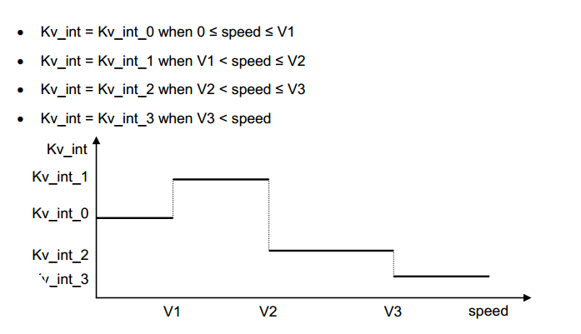

**AGrd** : Acceleration Gradient due to the slope of gravity centre, is determined following worse case of slope over the train length. AGrd is defined following position (x) by a scan from LRGB up to final target ( ie : EOA / SvL). The result depends on events “Grade Changes”. Gravity Acceleration is taken as 9.81m/s². See **SRS-026-3-13-4**.

**Asafe** : Acceleration safe is sum of AEB and AGrd, taking in account the rotating mass coefficient ”alpha” :

Asafe * M * (1 + alpha) = AEB * M * (1 + alpha) + AGrd * M

or

Asafe = AEB + (AGrd / Alpha)

with Alpha = 1 + alpha

**A_expected(v, d)** : Acceleration Service Brake is submitted to gradient and factor correction.

**Build-up Time** : the following parameters in relation with time have to be defined :

T1 : time to TCO ( traction cut off )

Ttraction : T1

Aest1 : acceleration during T1  
 Vdelta1 : speed increase during T1

T2 : time to establish EB ( emergency brake)

Tberem : T2

Aest2 : acceleration during T2

Vdelta2 : speed increase during T2

Tbs1 : time between SBI1 and SBD ( service brake intervention to deceleration )

Tbs2 : time between SBI2 and EBI ( separate EB with SB )

Tdriver : driver delay ( for DMI commands )

Twarning : warning delay

Tind : indication delay

See **SRS-026-3-13-6.**

**MRSP** : Most Restrictive Speed Profile, taking into account SSP, TSR, Max Train Speed, Train Length. MRSP is defined following position (x) by a scan from LRGB up to final target with speed 0. The result depends on both events SSP and TSR as well on system data. See **SRS-026-3-13-7.**

**Target** : Most Restrictive Energy constraint is defined by a scan from final target up to Train Max Front End, that is in opposite direction of DOT. One possible target appears at each speed decreasing of MRSP. A comparison between authorised energy and kinetic energy could define a most restrictive displayed target (MRDT, see drawing hereafter).

Train Max Front End

Change of Target

Final Target

(MRDT)

Initial Target

AEB Change

**EB_Ener + G_Ener > Cor_Ener + K_Ener**

**EB_Ener + G_Ener < Cor_Ener + K_Ener**

Targets Research

**SvL / EOA / Release Speed :**

Release Speed is used to permit the approach of EOA.

* When EOA is a limit of Interlocking Area, it needs to be protected by a “Supervision Limit” (SvL) which can be a “Danger Point” (DP) or an “Overlap” (OL). There is a double protection :
  + The SvL is protected by EBD, EBI and SBI2 curves,
  + EOA is protected by SBD and SBI1 curves,
  + A release speed permits a safe approach of EOA.
* When EOA is a limit of Block, SvL is implemented at EOA location and protected by EBI and SBI curves as long as estimated speed is over Release Speed.
* In any case, the overpassing of EOA by “Min Safe Front End” triggers an EB.

The drawing hereafter is used to estimate the function giving the distance from EOA to SvL (so-called Dbec) in relation with the release speed :

Aeb = Deceleration average on Debc, following grade, adhesion, etc..

Vbec and Dbec are output :

Vbec = V_Release + (Aest1 * T1) + (Aest2 * T2)

Dbec = x0 + x1 + x2 + M

With intermediate computation :

x0 = Vebc² / ( 2 * Aeb )

x1 = (V_Release * T1) + ( Aest1 * T1²) / 2

x2 = ((V_Release + (Aest1 * T1)) * T2) + ( Aest2 * T2²) / 2

M = margin = (max front end - min front end) + (antenna distance to front end)

EOA

SvL

EBI

EBD

SBD

Release Speed

x0

x2

x3

M

x1

**Vebc**

**Debc**

**V_Release**

**LOA**

**LRBG**

SvL / EOA / Release Speed

**Ceiling / Target / Ceiling Speed Monitoring :**

The sequence ceiling / target / ceiling ocurs at each MRPS reduction. Let be MRSP1 < MRSP2.

MRSP1 is a Permit Speed within a CSM status.

MRPS2 is a Target Speed during the TSM status.

MRPS2 is again a Permit Speed when recovering CSM status.

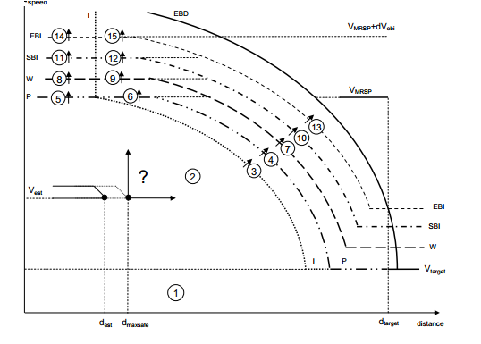

**CSM2**

**CSM1**

**TSM**

**dVeb**i

**dVeb**i

MRSP2

MRSP1

MRSP Reduction

It exists 6 curves defining 5 areas, each area being split into 3 cases :

* 1, 2, 3 : **Normal Status**, Train is below the permit speed,
* 4, 5, 6 : **Overspeed Status**, Train is below the warning speed, but over the permit speed,
* 7, 8, 9 : **TCO Status**, Train is below the SBI curve, but over the warning speed, Traction is cut off,
* 10, 11, 12 : **Intervention SB Status**, Train is below EBI, but over SBI, SB is active,
* 13, 14, 15 : **Intervention EB Status**, Train is over EBI, EB is active.

## Structure

Structure is based on one vector per each event.

All vectors are classified following their position.

Empty vectors (type= 0) are used between events.

Several events could be at same position ( 2 events ).

It is anticipated that :

* One vector is 100 bytes,
* Data-Base is supporting 10 km of track,
* One increment of position is 1 m
* Total size is : 10 000 x 100 bytes = 1 MBytes

Position Inc. Type DOT. Data1 Data2 AEB AGrd MRSP Target EB_ G_ K_ Corr_ENER

Energy Computation :

EBD, EBI, SBD,

SBI1, SBI2

DMI curves : W, P, I

See Events Definition

Preliminary Computation

Follows odometry

(step = 1 m )

Train Running Direction

Data from Packets

Vector and Matrix of Database

## Energy Computation

Energy computation is based on SRS model hereafter .

All EBI curve parameters for braking to target supervision limit are defined within the drawing hereafter :

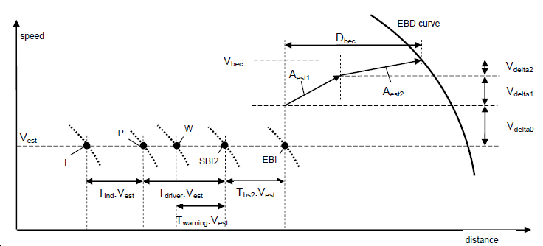

Braking :

xb, vb, hb

Origin :

,x0, v0, h0

Target :

x1, v1, h1

Braking Curves Model

The energy balance shall be applied for every curves : EBI, SBI, W, P, I.

Considering that train speed is “Vest” and is constant over various delays associated to W, P, I, the Max Front End shall permit to define a supervision status not limited to “Intervention” of EB or SB, but also be extended to DMI :

(Brake_Energy) + (Potential_Variation_Energy) :: (Kinetic Variation Energy) + (Response_Correction)

**(EB_ENER + G_ ENER) :: (K_ENER + Corr_ENER) :** With the following development :

* + Kinetic Variation Energy = ½ (v0² - v1²)
    - * this value concerns the total mass : M * (1+alfa)
      * alfa is 15% in uphill and 2% in downhill
  + Emergency Brake Energy = (x1 – x0) * Aeb
    - * this value concerns the total mass : M * (1+alfa)
      * Aeb is the emergency brake deceleration
      * Aeb is a function of x and v
      * then EB as SB Energy between two locations will require an integration step by step
  + Response_Correction = ½ [ (Aest1* T1)² + (Aest2*T2)²] +(Dbec * Aeb)
    - * this value concerns the total mass : M * (1+alfa)
      * response is in 2 phases, lasting T1 and T2,
      * the running distance is so-called Dbec,
      * Dbec = ½ ( Aest1 * T1² + Aest2 * T2² ) + v0 * (T1 + T2)
      * Aest1 = estimated initial acceleration
      * T1 = time to cut off traction power
      * Aest2 = estimated acceleration prior to full emergency braking
      * T2 = time to reach full emergency braking
      * Others delays (Tbs, Twarning, Tdriver, T_ind) shall be added to Max Front End position as indicated in drawing “Braking Curves Model” and under assumption of Vest is constant all over delays.
  + Potential _Variation_Energy = (h1 – h0) * g / Alpha
    - * this value concerns only the mass M,
      * g = 9,81 m/s² must be taken into account,
      * potential energy must be compensated by division with Alpha = 1+alpha,
      * h1 – h0 is integration of function Grade(x) between x0 and x1.

EB-ENER and G_ENER can be grouped into integration of function Asafe( x, v) :

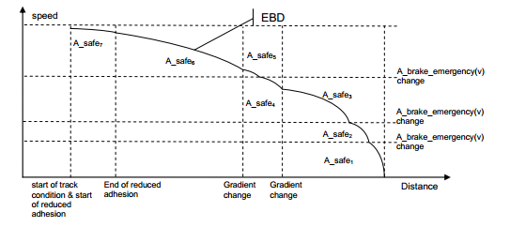

Speed / Distance integration by part

# Commands of Speed and Distance Monitoring

## State Machine

A “State Machine” is used to design the monitoring of “Speed and Distance”.

Three states are necessary :

* Ceiling Speed Monitoring (CSM),
* Target Speed Monitoring (TSM),
* Release Speed Monitoring (RSM).

Two conditions are used :

* [c1] : {Max Safe Front End over EBD_I } or {Estimated Front End over SBD_I}
* [c2] : {Max Safe Front End over RSM start }

CSM

TSM

RSM

c1

c2

notc1

not c1

The transition [c1] is used when there is no stop, that is to manage the transition between :

* “ceiling speed” mode,
* and “target speed” mode.

The transition [c2] is used when there is a stop, that is to manage the transition between :

* “”release speed” mode,
* and “ceiling speed” mode,

## Speed and Distance Diagram

CSM and RSM are simple modes that are addressed by logical equation.

TSM is a complex mode that needs to be addressed following 2 cases :

* CSM / Target / RSM,
* CSM / Target / CSM.
* corresponding to the transitions [c1] and [c2].

### Ceiling / Target / RSM

This configuration is addressing a stopping point associated to :

* one limit of section or,
* one limit of end-section.

This limit of section can be :

* one simple EOA without definition of DP and OL, then :
  + it’s up to the designer to estimate an actual DP unknown by on-board,
  + V_Release is imposed by trackside or by national value,
  + SBD starts from EOA,
  + EBD starts at SvL in compliance with V_Release,
  + SBD is removed below V_Release.
* one EOA with definition of DP and/or OL, then :
  + V_Release can be :
    - computed through distance EOA to DP, or
    - imposed by trackside, or
    - provided by national value,
  + SBD starts from EOA,
  + EBD starts from DP or OL,
  + SBD and SBI are removed below V_Release.

Figure 56 of chapter 3.13.10.4 is describing the distance versus speed diagram.

Table 9 of chapter 3.13.10.4 is describing the 15 status through active transition.

Table 11 of chapter 3.13.10.4 is describing the revoking transition.

Note 1 : SBD curves, EBD curves, V_RELEASE and V_MRSP are the basis of speed and distance diagram.

Note 2 : SBD and SBI1 curves are the first curve to be calculated, assuming that SBD is starting at EOA (compliance with 3.13.8.4), and SBI1 is starting from SBD at a distance “Tbs1 * V_RELEASE”. The foot of SBI1 is the start RSM border.

Note 3 : Other curves (W, P, I) are computed through respective delays Twarning, Tdriver, Tind, in compliance with 3.13.9.3.

Note 4 : intersection of I curve with V_MRSP defines the border CSM / TSM.

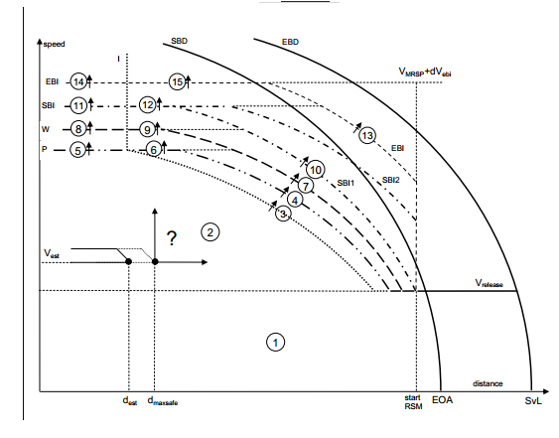

TSM / RSM

CSM / TSM

EB

SB

EB

W

I

P

Ceiling / Target / RSM Diagram

Nota 1 : “d est” or “d est front” is the nominal train position given by odometer.

“d max safe” or “d max safe front” is the maximum train position given by odometer.

Nota 2 : “di(Vest) is the “Indication” curve position related to train speed.

“dp(Vest) is the “Permit” curve position related to train speed.

“dw(Vest) is the “Warning” curve position related to train speed.

“dsbi1(Vest) is the “SBI1” curve position related to train speed.

“dsbi2(Vest) is the “SBI2” curve position related to train speed.

“debi(Vest) is the “EBI” curve position related to train speed.

Nota 3 : “di(Vmrsp) is the “Indication” curve position related to MRSP speed.

“dp(Vmrsp) is the “Permit” curve position related to MRSP speed.

“dw(Vmrsp) is the “Warning” curve position related to MRSP speed.

“dsbi1(Vmrsp) is the “SBI1” curve position related to MRSP speed.

“dsbi2(Vmrsp) is the “SBI2” curve position related to MRSP speed.

Nota 4 : I, P, W, SBI1, SBI2 are obtained through times Tind, Tdriver, Twarning, Tbs1 and Tbs2.

Nota 5 : debi(v) and debd(v) must be the first curves to be computed through integration of Asafe(v,d) and response delays T_traction and T_berem. The MRSP imposes speed limitation. Computation should be done by step of 1 m/s from SvL up to reach train front end position.

### Ceiling / Target / Ceiling

#### Analysis

This configuration is addressing speed reduction with transitions similar to Ceiling To Target RSM.



SB

TSM / CSM

CSM / TSM

EB

I

W

P

Ceiling / Target / Celing Diagram

This configuration is addressing a MRPS reduction, that supposes :

* one switch from ceiling mode to target mode,
* one switch from target mode to ceiling mode.

Figure 55 of chapter 3.13.10.4 is describing the distance versus speed diagram.

Table 8 of chapter 3.13.10.4 is describing the 15 status through active transition.

Table 10 of chapter 3.13.10.4 is describing the revoking transition.

Note 1 : EBD curve, EBI curve, V_TARGET and V_MRSP are basis of speed and distance diagram.

Note 2 : EBI curve is below EBD curve, while EBI curves are above V_TARGET and V_MRSP.

Note 3 : TSM / CSM border is positioned at the MRSP speed reduction.

Note 4 : EBD curve is crossing EBI at TSM /CSM border, in compliance with 3.13.8.3.

Note 5 : Other curves (W, P, I) are computed through respective delays Twarning, Tdriver, Tind.

Note 6 : intersection of I curve with V_MRSP defines the border CSM / TSM.

#### Synthesis

This configuration needs to be involved at each potential target, that is :

* at each speed reduction of MRSP,
* at each LOA.

EBI Curve

V_Target

Indication Curve

EBD initial position Xb,Vb

V_MRSP

V_MRSP + dV_ebi

V_Target + dV_ebi

CSM_1

CSM_2

TSM

Ceiling / Target / Celing Synthesis

The equation giving the speed “V” related to position “X” is :

V = MAX { MIN {SQRT [Vb² - 2 * (Xb – X) * Asafe(X)] ; (V_MRSP +dV_ebi) } ; (V_Target +dV_ebi ) }

### CSM / TSM State Machine

A State Machine of 6 states will manage the CSM and TSM process.

Both processes are exclusive, one sole diagram will address the process.

The 15 active transitions of both diagrams are involved (t1..t15).

Four additional revocation transitions are necessary (r0..r3).

EB int.

SB int.

Warning

Oversp.

Indicat.

Normal

t3

t4, t5, t6

t7, t8, t9

t10, t11, t12

t13, t14, t15

r1, r2

indication

Indication

# Speed Supervision limits

## references

UNISIG Subset_026 version_3.3.0

Chapter 3 : ERTMS / ETCS Principes

Chapter 5 : ERTMS / ETCS Procedures

Chapter 7 : ERTMS / ETCS Language

## overview

[SRS-026-chapter : 3.13.9.3]

Braking to target supervision limits consists in computation of EBD, EBI, SBD, SBI, W, P and I curves. GUI curve is not addressed.

## EB Supervision Computation

The objective is to establish mathematic formula which link train position and particular location requirement (for instance : “train position” versus “trackside target”).

It is defined 3 particular locations :

* Origin :
  + x0 : location where the EB intervenes,
  + v0 : speed at location x0, so-called “Vest”, can be increased by inaccuracy,
  + h0 : height of gravity centre at x0.
* Braking :
  + xb : location where the EB is active after two phases of transition,
  + vb : speed at location xb, is v0 increased after 2 phases of transition,
  + hb : height of gravity centre at xb.
* Target :
  + x1 : target location,
  + v1 : target speedn
  + h1 : hight of gravity centre at target.

The next computation will be done through physical mechanic theory in “Energy” by mass unit (m²/s²) between origin and target.

Supervision Limits computation must include 3 items :

* Target Speed :
* Ceiling Speed :
* Release Speed :

## Supervision Computation example

See Excel File attached.

<ClasseurCalculCurves.xlsx>

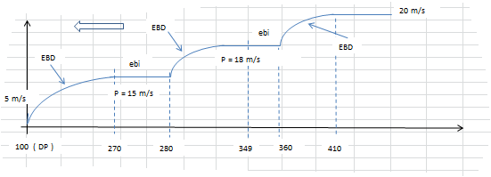

### Inputs :

Position : odometer counter, nominal value, increasing or decreasing following running orientation. Here, train running in decreasing orientation.

Type : defines the nature of event (see database definition).

p1, p2, p3 : parameters linked to each event type.

Asafe_1 : Asafe value to take into account when MRSP is lower than V1.

Asafe_2 : Asafe value to take into account when MRSP is upper than V1.

Asafe_3 : Asafe spare

Aest1 : acceleration during TCO.

Aest2 : acceleration between TCO and EB, should be given by odometer.

DeltaV : speed increase between EBI and EBD.

step : quantum of distance.

V1 : threshold between Asafe_1 and Asafe_2.

T_traction : TCO delay, so-called T1.

T_berem : EB delay, additional to TCO delay, so-called T2.

Tbs2 : SB delay related to EBI, corresponds to SBI2.

Twarning : W delay related to SBI2 curve.

Tdriver : P delay related to SBI2 curve.

Tind : I delay related to P curve.

Tbs1 : SB delay related to SBI, corresponds to SBI1.

dV_ebi : function of V_MRSP and of :

V_ebi_min :

dV_ebi_min :

V_ebi_max :

dV_ebi_max :

C_ebi :

dV_sbi : function of V_MRSP and of :

V_sbi_min :

dV_sbi_min :

V_sbi_max :

dV_sbi_max :

C_sbi :

dV_w : function of V_MRSP and of :

V_w_min :

dV_w_min :

V_w_max :

dV_w_max :

C_w :

dV_w = 0.

### Outputs and formula :

#### **Preliminary**

Asafe : current safe deceleration value used for EBD and EBI curves, by integration of EB deceleration, Adhesion factor, Grade changes, up-hill and down-hill indicator, Train length, Rotative Mass coefficient.

V_MRSP : current speed value of Most Restrictive Speed Profile, by integration of SSP, TSR, ASP and Train Length.

dV_ebi : authorized delta speed value in CSM before EB Intervention.

dV_sbi : authorized delta speed value in CSM before SB Intervention.

dV_w : authorized delta speed value in CSM before Warning.

V_Target : V_MRSP reduction, the most restrictive being MRDT.

#### **Emergency Brake Curve**

Vbec : maximum possible speed to meet MRSP in accordance with Asafe, defines EBD curve in TSM. This curve is always between V_Target and V_MRSP + dV_ebi.

Vbec(n) = MIN( SQRT (Vbec(n-1)² + 2*step*Asafe(n-1) ); (V_MRSP + dV_ebi) )

Dbec : maximum possible distance to establish EB.

Dbec = ½ * (Aest1 * T1² + Aest2 * T2²) + (V0 * (T1 + T2))

V0 : speed coordinate of EBI curve, and then SBI, W, P, I curves.

V0 = Max ( Vbec – (Aest1 * T1 + Aest2 * T2); 0 )

X0 : distance coordinate of EBI curve.

X0 = Position + Dbec

Xsbi2 : distance coordinate of SBI2 curve.

Xsbi2 = X0 + (Tbs2 * V0)

#### **Service Break Curves**

Vsbd : define SBD curves starting from EOA if any. Asb is deceleration of SBD.

Vsbd(n) = MIN( SQRT (Vsbd(n-1)² + 2*step*Asb(n-1) ); (V_MRSP + dV_sbi) )

Vsbi : define SBI curves starting from EOA if any. Tsb is delay to SBD.

Vsbi = Max ( Vsbd – (Asb * Tbs); 0 )

Xsbi1 = Position

#### **TIU and DMI Curves**

C/T/RSM : type of Speed Monitoring :

= 1 : CSM,

= 0 : TSM,

= -1 : RSM.

IF ( ( V_MRSP = V_Release ); -1)

IF ( ( ( V_MRSP + dV_ebi) = Vbec ); 1; 0)

Xsb : compile Xsbi1 and Xsbi2

Xw : distance coordinate of Warning curve.

Xw = Xsb + (Twarning * V0)

Xp : distance coordinate of Permit curve.

Xp = Xsb + (Tdriver * V0)

Xi : distance coordinate of Indication curve.

Xi = Xp + (Tind * V0)